STROKE - ED POSTING
Altelase use July 2017 – June 2018: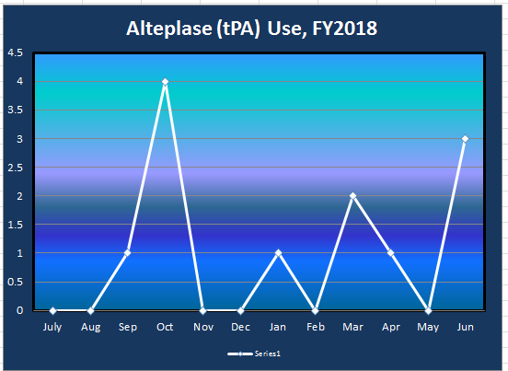

Alteplase Use July 2018 – August 2018:
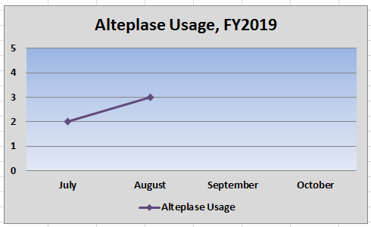

Door to Needle Time since July 2018 – Goal (from Joint Commission) is under 60 min, at least half the time:
