Converting Powerpoint Slide To a Theme Template

Open the powerpoint presentation.
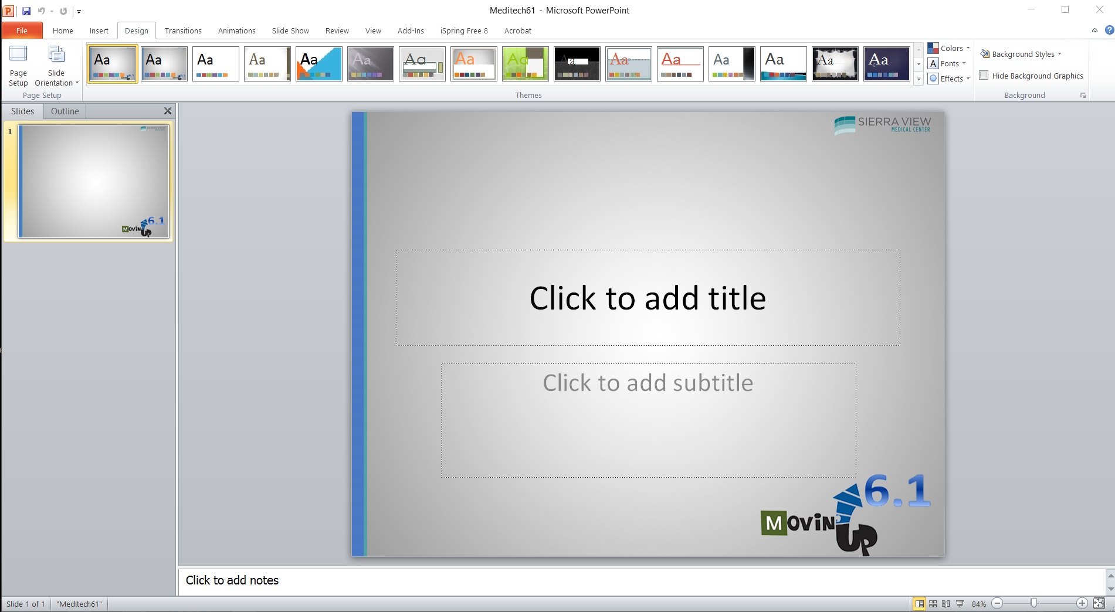

Select the Design Tab.
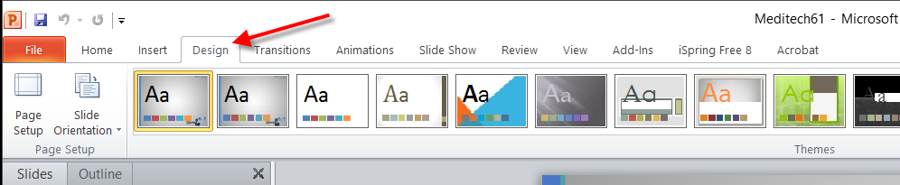

Here you can see all of the themes across the ribbon. To add this design to the Theme library, Click FILE/SAVE AS. Then type the file name you want the theme to appear as. Lastly, change the “Save as type” field to “Office Theme”. Now click Save. The new theme will now appear in the Themes Library.
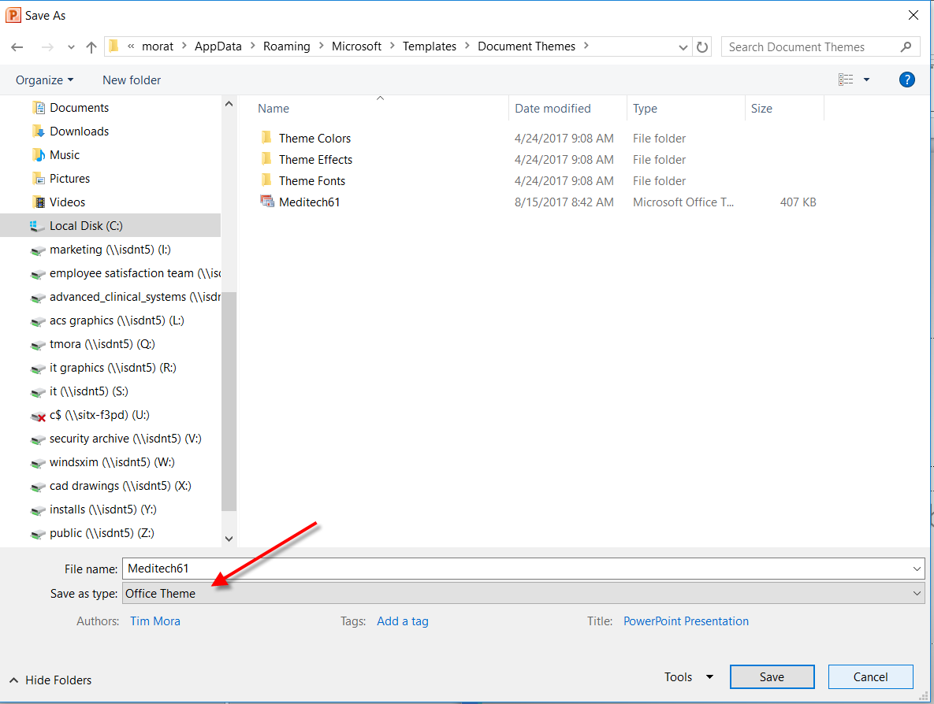

Here you can see the tool tip pop up showing the new Theme. Just click it to use the theme.
