How to locate a PCP
-Open webpage: https://www.uhcprovider.com/en/find-a-provider-referral-directory.html

-Select “Search for a Provider”

-Select “Medical Directory”
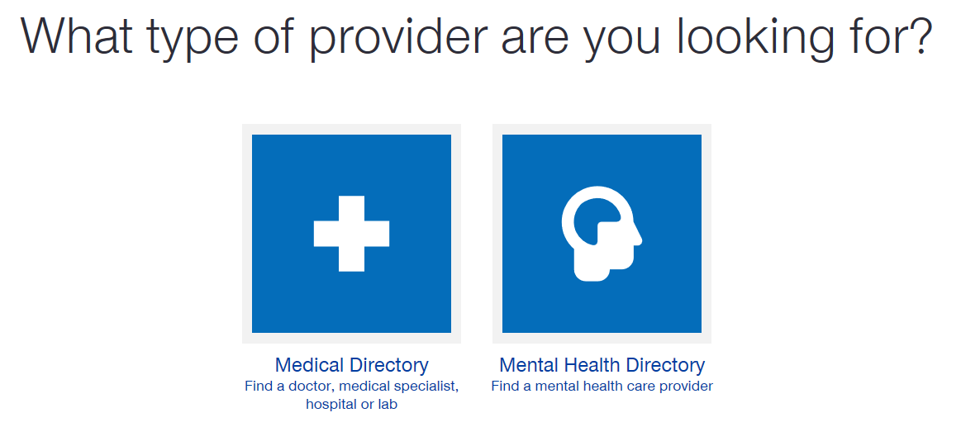

-Select “All UnitedHealthcare Plans”
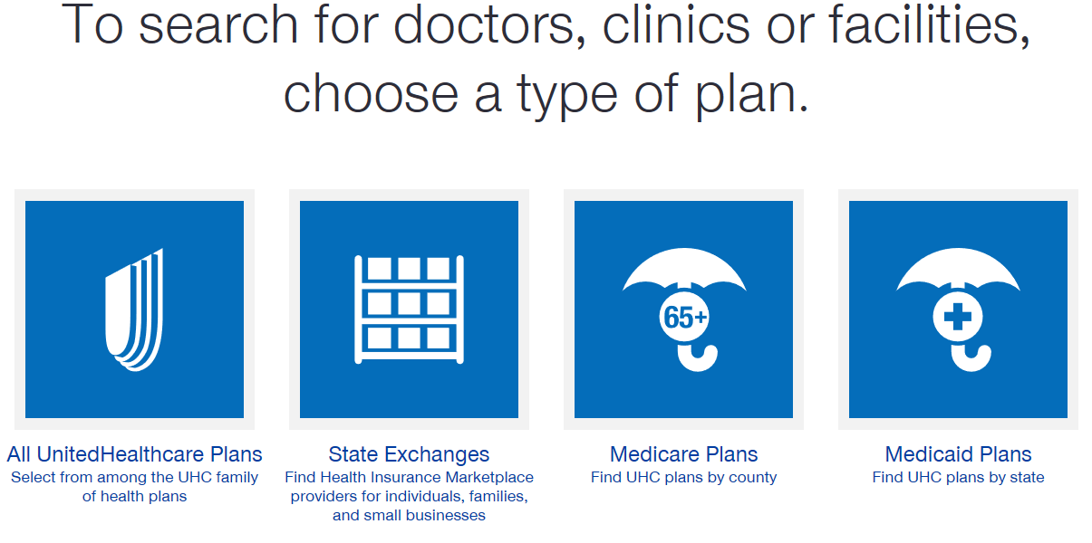

-Scroll Down to locate “SignatureValue Plans”

-Select “Medical Directory”

-Choose your State:
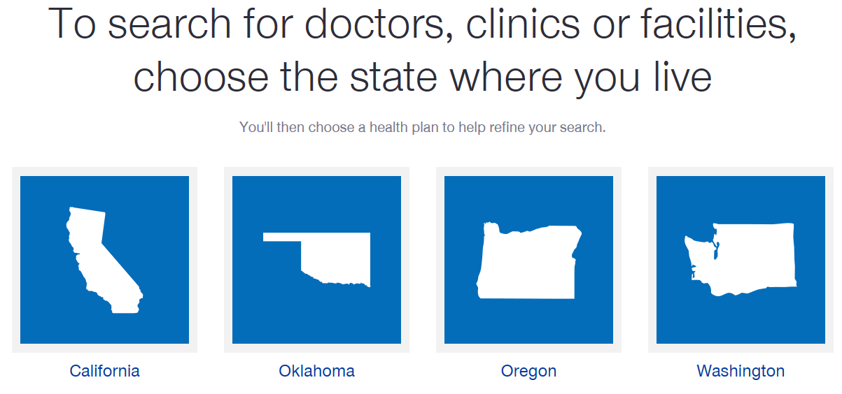

-Select “No” for Federal Employee:
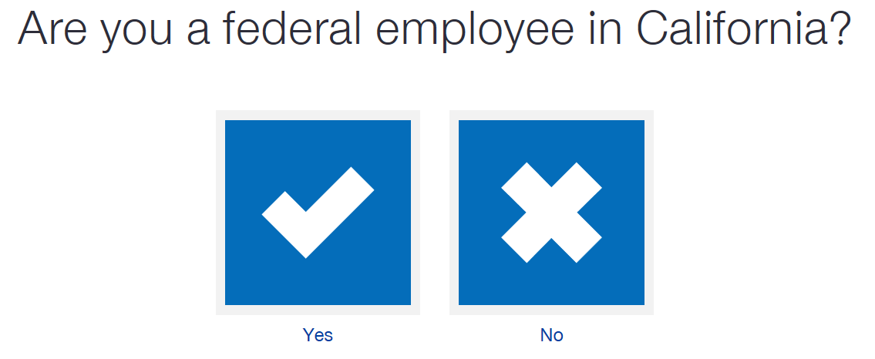

-Select the “SignatureValue HMO”

-Enter your zipcode and press continue:
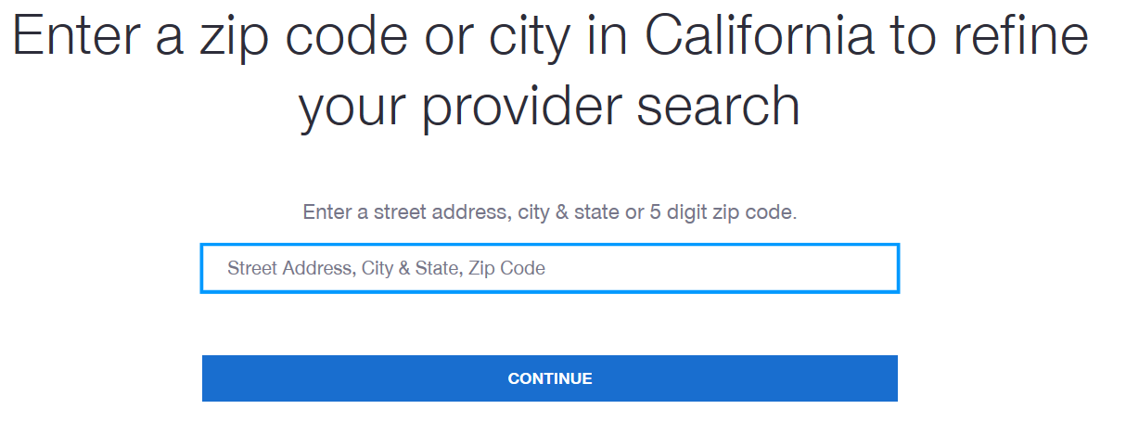

-Search by Provider name or choose a category
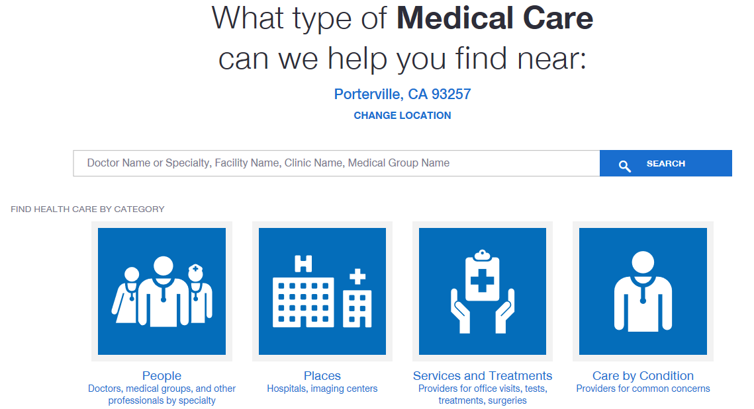

-Once you have located the doctor/facility – click on the locations tab
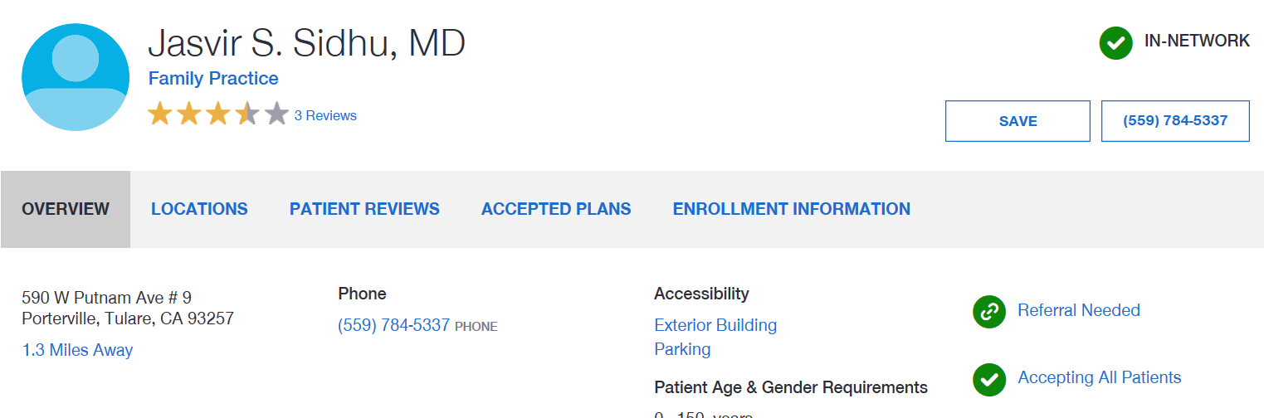

-Under Locations you will find the ID #
